Department of Information Technology
Academic Year: 2024-25 Name of Student:
Semester: VI Student ID:
Class / Branch / Div: TE- IT A/B /C Roll No. Subject: MAD & PWA Lab Date of Submission: Name of Instructor:

Experiment No.:6
Aim: Apply concepts of gestures in Flutter App.

Prerequisites: Android studio, flutter SDK.
Problem Statement: To develop a flutter UI using GestureDetector widget of flutter.
Software: Android studio, flutter SDK. Code:

import 'package:flutter/material.dart'; void main() {
runApp(MyApp());
}
class MyApp extends StatelessWidget { @override
Widget build(BuildContext context) { return MaterialApp(
home: ZoomExample(),
);
}
}
class ZoomExample extends StatelessWidget { @override
Widget build(BuildContext context) { return Scaffold(

appBar: AppBar(
title: Text("Zoom In / Zoom Out Demo"), centerTitle: true,
),
body: Center( child: Column( children: [ Text(
"A.P.Shah Institute Of Technology",
),
InteractiveViewer( minScale: 0.5,
maxScale: 4.0, child: Container( width: 200,
height: 200, color: Colors.blue,
alignment: Alignment.center, child: Image.network(
"https://encrypted-tbn0.gstatic.com/images? q=tbn:ANd9GcQJPPyOSEbL6At941ERqur_RDKeQhxIrqEKKw&s",
),
),
),
],
),
),
);
}

}
Output:

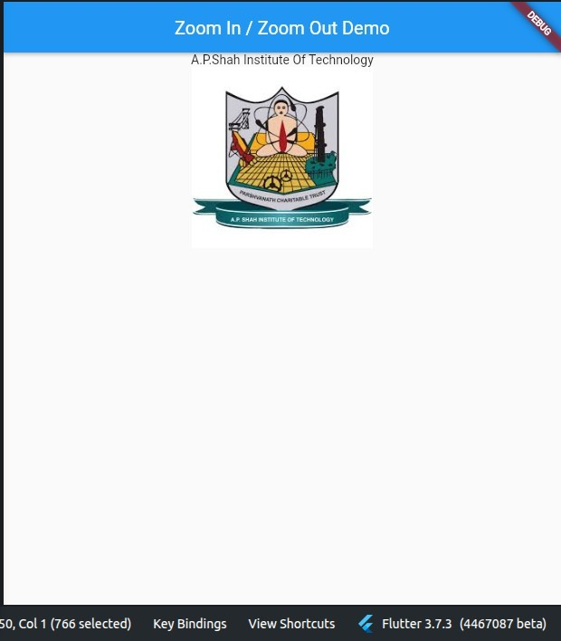
Code:
import 'package:flutter/material.dart';

void main() => runApp(MyApp());
class MyApp extends StatelessWidget { @override
Widget build(BuildContext context) { return MaterialApp( debugShowCheckedModeBanner: false, title: 'Flutter Demo Application', theme: ThemeData(
primarySwatch: Colors.green,
),
home: MyHomePage(),
);
}
}
class MyHomePage extends StatefulWidget { @override
MyHomePageState createState() => MyHomePageState();
}
class MyHomePageState extends State<MyHomePage> { @override
Widget build(BuildContext context) { return Scaffold(
appBar: AppBar(
title: Text('Gestures Example'), centerTitle: true,
),
body: Center(
child: GestureDetector( onTap: () {

print('Image Clicked');
},
child: Container( height: 300,
width: 200,
child: Image.network( "https://picsum.photos/300", // changed image fit: BoxFit.cover,
),
),
),
),
);
}
}
Output:
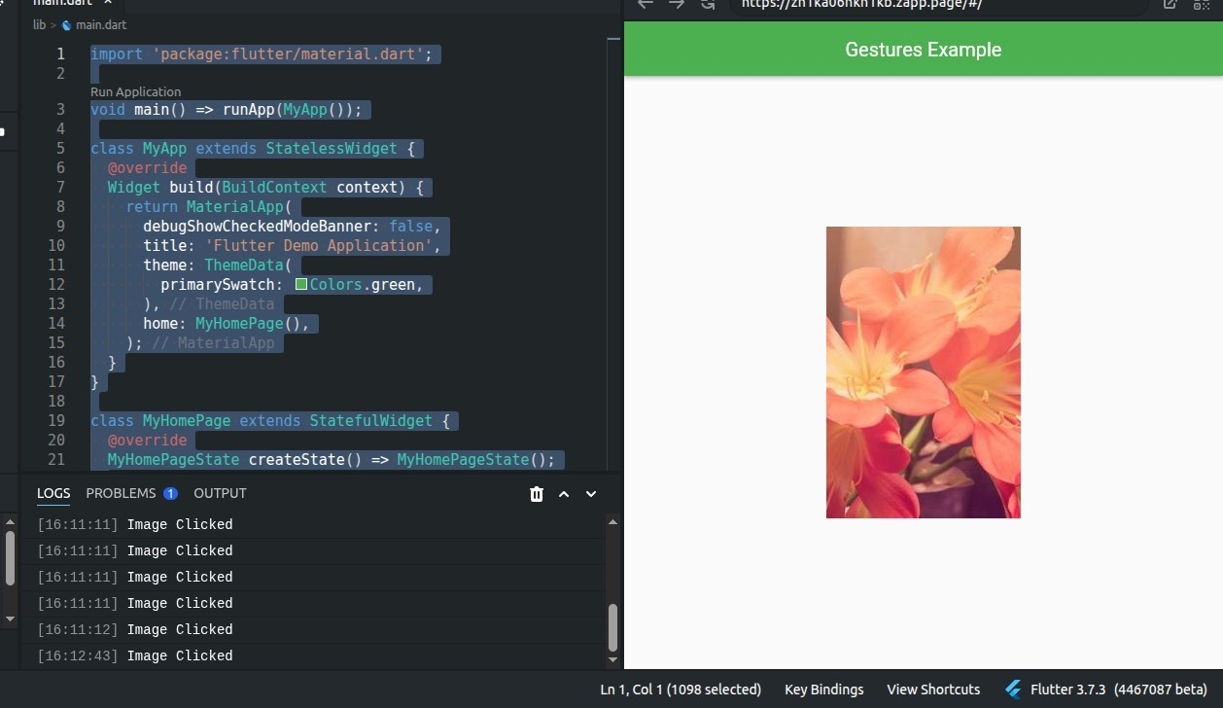

import 'package:flutter/material.dart';

void main() => runApp(MyApp());

class MyApp extends StatelessWidget { @override
Widget build(BuildContext context) { return MaterialApp( debugShowCheckedModeBanner: false, title: 'Flutter Demo Application', theme: ThemeData(
primarySwatch: Colors.green,
),
home: MyHomePage(),
);
}
}

class MyHomePage extends StatefulWidget { @override
MyHomePageState createState() => MyHomePageState();
}

class MyHomePageState extends State<MyHomePage> {

String message = "This is an APSIT logo";

@override
Widget build(BuildContext context) { return Scaffold(
appBar: AppBar( title: Text('APSIT'), centerTitle: true,
),
body: Center( child: Column(
mainAxisAlignment: MainAxisAlignment.center, children: [

GestureDetector( onTap: () {
setState(() {
message = "This is IT logo";
});
},
child: Container( height: 300,
width: 200,
child: Image.network(
"https://encrypted-tbn0.gstatic.com/images? q=tbn:ANd9GcQJPPyOSEbL6At941ERqur_RDKeQhxIrqEKKw&s",
fit: BoxFit.cover,
),
),
),

SizedBox(height: 20),

Text( message,
style: TextStyle(fontSize: 20, fontWeight: FontWeight.bold),
),

],
),
),
);
}
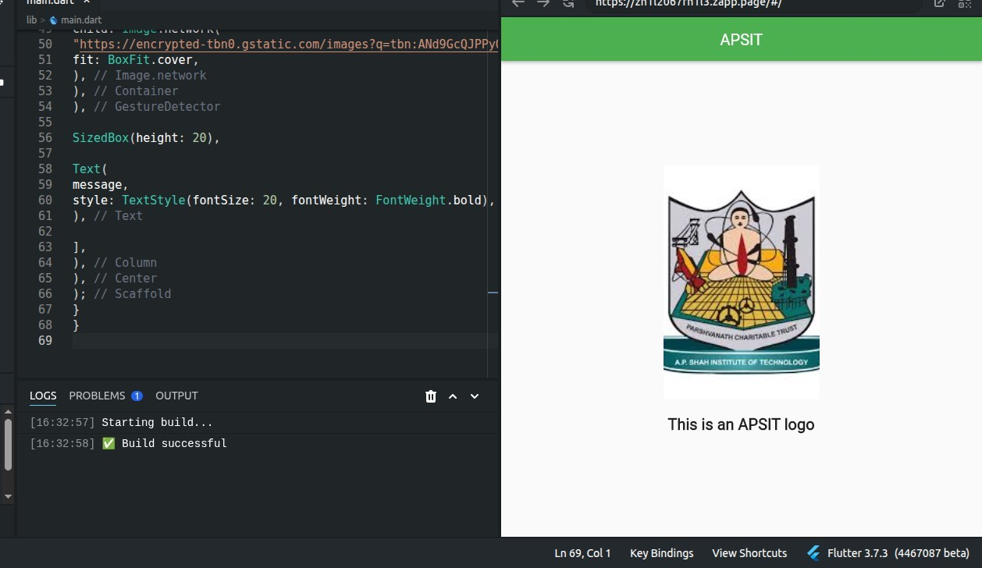
}

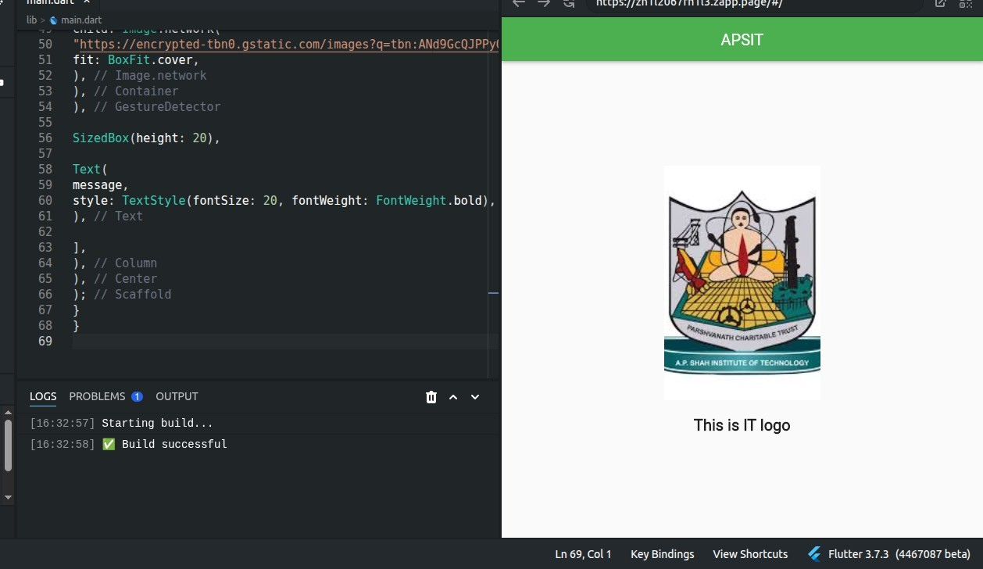

Conclusion: In this experiment, we have successfully designed a flutter application using GestureDetector.

